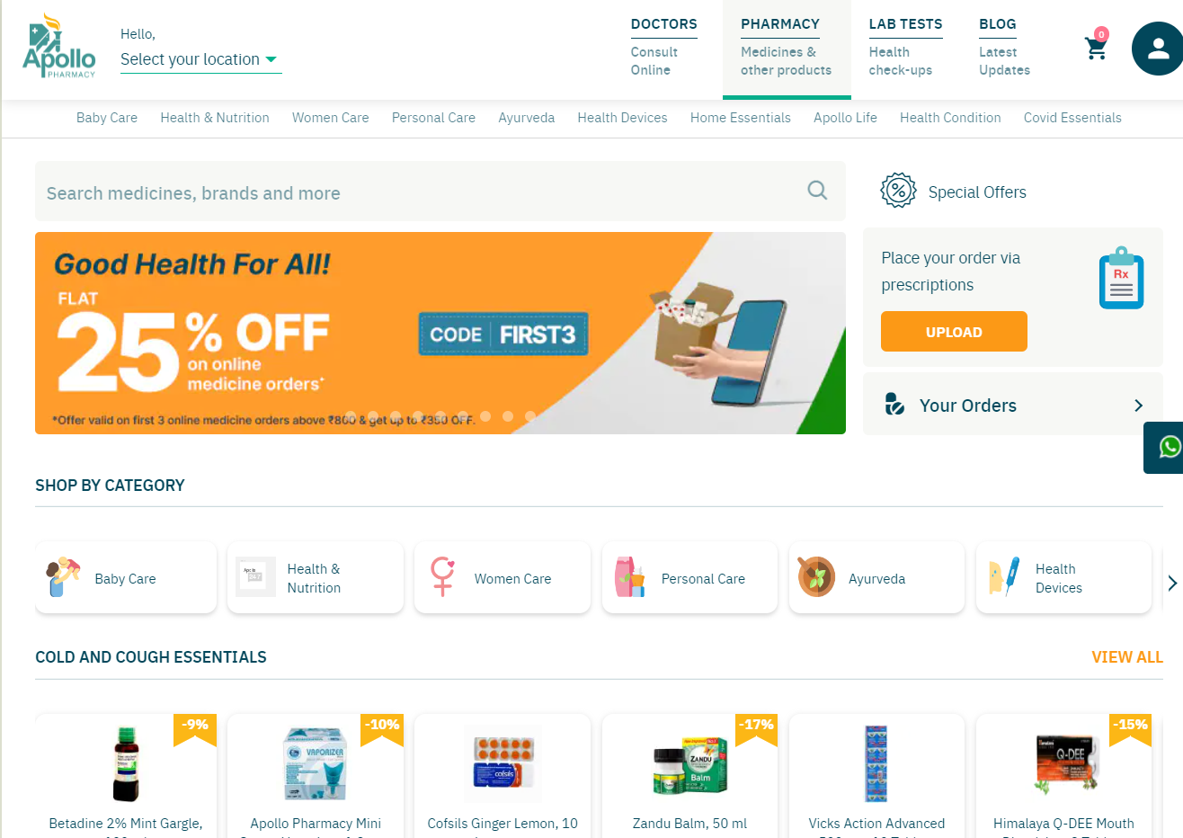

**Project Name*:*** *Apollo pharmacy*

Website Link: <https://www.apollopharmacy.in/>

***Project By:*** Jeevan Kumar S

**Overview**

Apolloharmacy.in is an online Medical Store, where we can buy medicines, Health & Wellness Product, Personal Care Items, ‎Ayurvedic & Herbal products online and will be delivered at your door step. Apollo Pharmacy is a part of Apollo Hospitals which is an Indian multinational healthcare

group with so many hospitals, pharmacies, primary care and diagnostic centres, and telehealth clinics through its subsidiaries.

**Goals**

1. Home page

* *Navigation bar*
* *Categories*
* *Profile icon*

1. Login page

* *Phone number login*
* *OTP to login*

1. Listing page

* *Products of a particular category*
* *Filter by*
* *Sort by*

1. Cart

* *Selected products*
* *Add or remove items*

1. Order review

* *Billed to*
* *Items*
* *Proceed to pay*

1. Payments

* *Payment options like* UPI*, wallets etc*

**Technologies used in Apollo pharmacy**

***Front-End:***

*1. Html*

*2. CSS*

*3. Bootstrap*

*4. React*

***Dynamic:***

*1. JavaScript*

*2. Ci/cd with AWS*

*3. Login and Logout (oauth and jwt)*

***Database:***

*1. MongoDB*

*2. JSON Data*

***Code compilers:***

*1. Visual studio code*

*2. Git bash*

*3. Git hub*

*4. Node.js*